1. Introduction 2
2. Objective 2
3. Methodology 2
3.1. Data Acquisition 2
3.2. Data Cleaning and Pre-Processing 3
3.3. Feature Engineering 3
3.4. Analytical Approach 3
3.5. Interpretation & Reporting 3
4. Data Design And Visualization 4
4.1. KPI Cards 4
4.2. Total Revenue by Month 5
4.3. Revenue Growth % by Month-Year 5
4.4 Total Revenue by Country 6
4.5. Average Order Value by Month 7
4.6. Customer Analytics Dashboard 7
5. Conclusion 7

Introduction
This report provides a comprehensive analysis of the Online Retail Sales Dashboard developed in Power BI. The dashboard consolidates key sales, customer, and product metrics into an interactive and visually intuitive format. By leveraging Power BI's analytical capabilities, this report aims to highlight business performance trends, uncover insights, and support data-driven decisions across sales, marketing, and operational teams.
The insights presented throughout the report are based on historical retail transaction data and include revenue performance, customer behavior analysis, product demand, and country-level sales distribution. Each section of the dashboard has been examined to provide clear interpretations and actionable observations.

Objective
The objective of this report is to analyze and interpret key metrics presented in the Online Retail Sales Dashboard developed in Power BI. Specifically, the report aims to:
- Evaluate overall sales performance using revenue, order volume, and quantity sold.
- Identify trends and patterns in monthly sales and revenue growth.
- Analyze customer behavior, including lifetime value, return rates, and purchasing patterns.
- Assess product performance to determine high-demand and low-performing items.
- Examine country-level contributions to overall revenue.
- Support informed business decision-making through data-driven insights.

Methodology
This section provides a detailed explanation of the systematic approach used to create, analyze, and interpret the Online Retail Sales Dashboard in Power BI. The methodology ensures that the dashboard insights are reliable, data-driven, and aligned with analytical best practices.

3.1. Data Acquisition
- The dataset used consists of transactional retail data containing fields such as InvoiceNo, StockCode, Description, Quantity, InvoiceDate, UnitPrice, CustomerID, and Country.
- Data was sourced in CSV format and imported into Power BI Desktop.
- Each row represents a line item from a customer invoice.

3.2. Data Cleaning and Pre-Processing
To ensure the dataset was suitable for analysis, the following steps were conducted:
- Handled Missing Values: Removed rows with missing CustomerID where required for customer-level analysis.
- Removed Invalid Entries: Excluded negative quantities (commonly representing returns) from sales metrics but included them for return-rate calculations.
- Standardized Fields:Converted InvoiceDate into separate fields such as Month, Year, and MonthName. Cleaned product descriptions by removing inconsistencies.
- Created Data Model: Ensured proper relationships between fact and dimension tables (Date, Customer, Product).

3.3. Feature Engineering
New calculated fields and measures were created using DAX (Data Analysis Expressions), including:
- Total Revenue = SUM(Quantity × UnitPrice)
- Average Order Value (AOV)
- Customer Lifetime Value (CLV)
- Revenue Growth % = (Current Month - Previous Month) / Previous Month
- Return Rate = (Negative Quantity Transactions / Total Transactions)
- Revenue per Customer = Revenue / Unique Customers
These measures enabled deeper analytical insights beyond raw transactional data.

3.4. Analytical Approach
A structured analytical process was followed:
- Trend Analysis: Examined month-over-month changes in revenue, orders, and AOV.
- Country-Level Comparison: Identified markets contributing the highest revenue, dominated by the United Kingdom.
- Customer Behavior Analysis: Investigated customer purchasing frequency, churn, and high-value customer segments.
- Product Performance: Ranked products by quantity sold and return rate to identify top sellers and problematic items.
- Correlation Observation: Compared revenue vs. order volume and return rate vs. product groups.

3.5. Interpretation & Reporting
- Each dashboard visual was analyzed to extract insights relevant to business decisions.
- Key findings were summarized into structured sections such as Sales Insights, Customer Insights, and Product Insights.
- The final report integrates data-driven interpretations with visual evidence from Power BI.

Data Design And Visualization
This section outlines the data model, transformation logic, and visualisation design used to create the Online Retail Sales Dashboard. The goal is to provide a cohesive analytical experience that enables stakeholders to understand revenue performance, customer behaviour, product-level insights, and country-level segmentation.
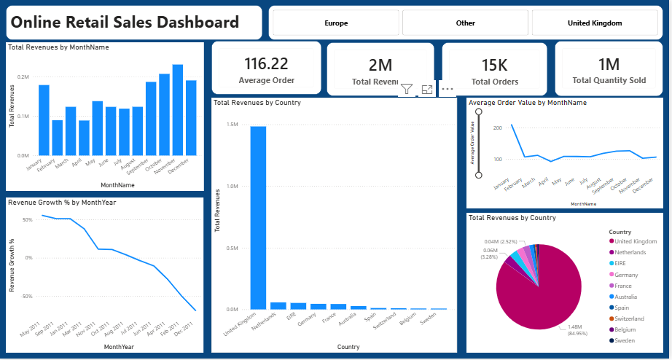

4.1. KPI Cards
The business currently serves 4,000 customers, each generating an average Customer Lifetime Value (CLV) of £391.08. The return rate stands at 9.62%, indicating the proportion of customers who make repeat purchases. Additionally, the company achieves a revenue per customer of £437.69, highlighting strong individual customer contribution to overall revenue.

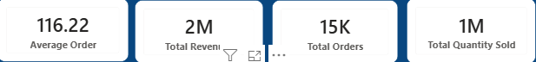

4.2. Total Revenue by Month
A column chart visualising monthly revenue trends.
Key Values
- Highest revenue month: November (~£230K)
- Lowest revenue month: March (~£125K)
- Revenue peaks in Q4, driven by holiday sales.
Insight
- Strong seasonal behaviour with significant revenue growth in November and December.
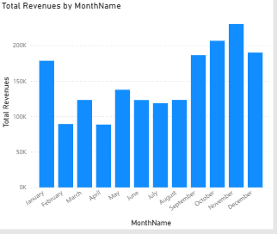

4.3. Revenue Growth % by Month-Year
A line chart showing month-over-month growth.
Notable Growth Rates
- May 2011: +55.40%
- September 2011: +51.14%
- December 2011: –68.79% (largest decline)
Insight
- Exceptional spikes in mid-year months show strong promotional or market-driven sales.

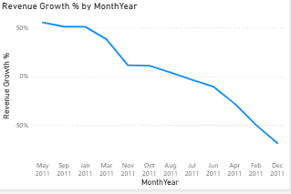

4.4 Total Revenue by Country
The Total Revenue by Country analysis shows a heavy reliance on the UK market, which contributes £1.48 million—84.35% of total revenue. Other countries generate comparatively small amounts: the Netherlands (£57,246), EIRE (£52,742), Germany (£45,226), and France (£44,039). While these markets add value, their impact is minimal compared to the UK, highlighting the need for greater market diversification and growth in international regions.

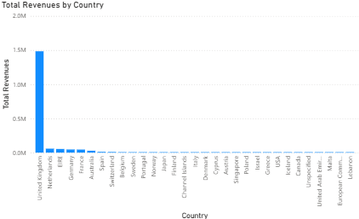

4.5. Average Order Value by Month
A line chart showing AOV fluctuations.
Range
- Highest: January – £209.11
- Lowest: April – £92.14
Insight
- AOV drops sharply after January, likely due to post-holiday clearance purchases

4.6. Customer Analytics Dashboard
The KPI cards offer a quick overview of customer performance. The business serves 4,000 customers, each generating an average Customer Lifetime Value of £391.08. The return rate is 9.62%, indicating a moderate level of product returns, while revenue per customer stands at £437.69, showing strong individual spending patterns. These metrics together provide a clear snapshot of overall customer value and behaviour.
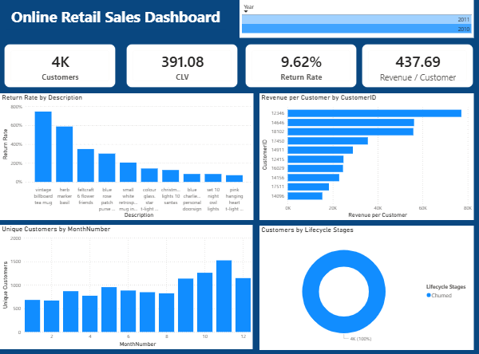

Conclusion
In summary, the Power BI Online Retail Sales Dashboard provides a clear, data-driven view of key business performance indicators. Through detailed analysis of sales trends, customer behavior, product performance, and country-level revenue distribution, the dashboard enables faster and more informed decision-making. The insights reveal strong seasonal patterns, high-value customer segments, and top-performing products, while also highlighting areas such as return rates and underperforming SKUs that require improvement. Overall, the dashboard serves as an effective analytical tool that transforms raw transactional data into meaningful insights, supporting strategic planning and operational efficiency across the business.

